**Course:** High Performance Computing Lab

**Practical No. 8**

PRN: 22510057

Name: Ashutosh Gundu Birje

Batch: B8

**Problem Statement 1:**

Study and implement 2D Convolution using MPI. Use a different number of processes and analyze the performance.

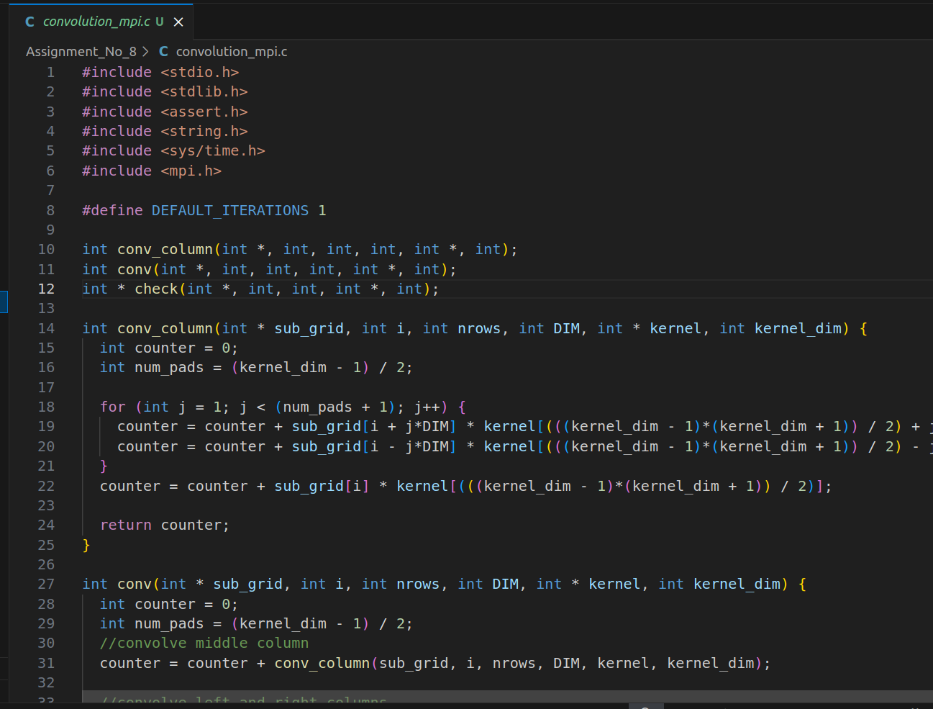

**Problem Statement 2:**

Implement dot product using MPI. Use different number of processes and analyze the performance.

